PAC-Poly-Marquesas-Bust

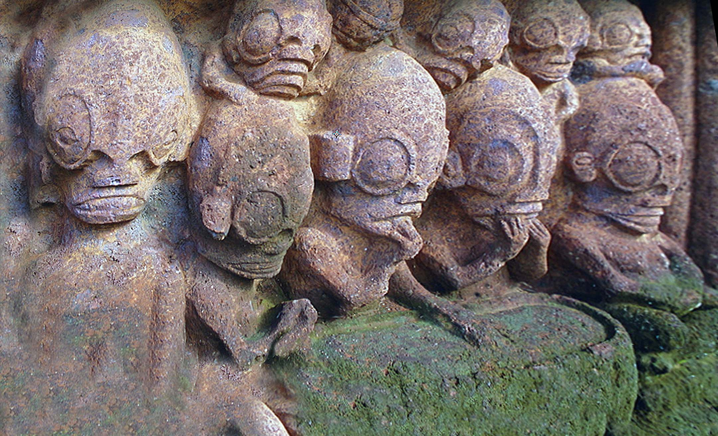



**Nuku Hiva, Taiohae Bay, Marquesas Islands, Maori *me‘ae* (*marae*).**

**This me‘ae (***marae****,*** in Hawai’ian) **is a** communal sacred place that provides a precinct that allows unfettered religious services to be conducted in all Polynesian societies.

 These sacred areas are rectilinear *me‘ae* (*marae*) terraces that are bordered with cobbles with a central upright megalith, an *ahu* or *a'u*, on one perimeter that is the place where consolidated deities inhere into it.

 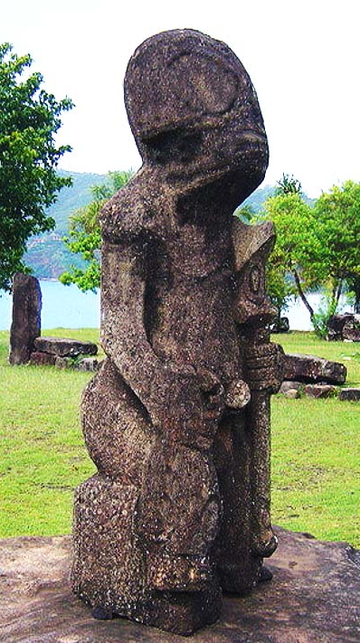

These figural displays in the Marquesas feature a unique wide-open eye that suggests a spiritual state, but to the left of this anthropomorphic statue of a warrior with a Uu Uu war club  is the aniconic ahu on the rectangular *me‘ae* (*marae*).

From http://apiemistika.lt/wp-content/uploads/2013/11/Nuku-Hivos-salos-skulpt%C5%ABr%C5%B3-paslaptis.jpg